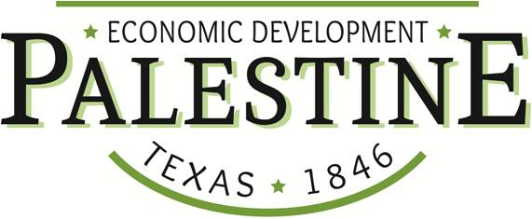
Downtown Matching Fund Grant Application

The Purpose:

The purpose of the Downtown Matching Fund Grant is to restore the existing downtown building stock to a condition that facilitates economic activity, downtown living, beautification and occupancy.

The Grant:

The Downtown Matching Fund Grant applies to existing properties located wholly within Palestine’s Historic Main Street District. The grant covers up to 50% of the contractor’s estimated project cost. Grant applications are limited to $75,000 per applicant. This grant will be administered annually based upon the availability of funds provided by the Palestine Economic Development Corporation.

The Project:

Properties eligible to receive assistance from the Downtown Matching Fund Grant will be located within the area defined as Palestine’s Main Street District. This grant does not apply to new construction and is intended to help with the renovation, beautification and improved functionality of existing structures.

Date:

Applicant Name:

Project Property Address:

Total Project Cost:

Grant Amount Requested:

Eligible Project Expenses: (all project expenses must be approved by PEDC)
Include but are not limited to interior and exterior materials and labor such as electrical systems and equipment, construction, framing, drywall, painting, plumbing systems and equipment , HVAC systems and equipment , masonry repair or replacement, asbestos abatement, roofing repair or replacement, structural repair or replacement, fire and smoke alarm systems, sprinkler systems and equipment , ADA improvements, façade improvements , streetscape improvements, landscaping improvements, etc.

Initial______________

Grant Payment:
Upon completion of the project, the applicant will submit paid invoices from the contractor who performed the work for all approved project expenses and receive 50% reimbursement up to the agreed upon grant total.

Initial______________

Property Insurance:
Until issuance of a Certificate of Occupancy, the Downtown Matching Fund Grant recipient shall maintain in force and shall provide evidence of a Builder's Risk Insurance Policy in the amount of the sum of the building value at the time of project commencement and all improvements being made to redevelop, restore and /or reconstruct the building. Existing building value shall be insured at actual cash value and improvement value shall be insured at replacement value. The Palestine Economic Development Corporation shall be a named insured on the Builder’s Risk Insurance Policy.

Initial______________

Sales Tax Assurance:
Grant Applicant gives assurances that a reasonable effort will be made to maximize sales tax payable to the City of Palestine on equipment and construction materials.

Initial______________

Grant Recapture:
In the event of default or partial non-compliance.
Should the Grant Recipient fail to complete the agreed upon project, the full grant amount shall be repaid as a default of grant conditions.

Initial______________

Commitment to Maintenance:
Recipients of grant money are required to maintain the funded improvements for a period of no less than 3 years from date of completion. The improvements are to be kept in optimum condition and in compliance with all applicable codes. The PEDC will make inspections throughout the compliance period to monitor compliance with the terms of the grant approval.

Initial______________

Applicant and Property Information:
Applicant name: ________________________________________________________
Mailing address: ________________________________________________________
Telephone: _____________________ Cell: _____________________________
Email: ________________________________________________________
Applicant is a [ ] corporation, [ ] partnership, [ ] proprietorship, or [ ] individual
Applicant is a [ ] property owner or [ ] tenant / lessee*
*If tenant, must return Letter of Property Owner Approval
Business name: _____________________________________________
Type of business: _____________________________________________
Property address: _____________________________________________
_____________________________________________
Legal description of property: _____________________________________________
_____________________________________________
Project Information:
Description of proposed improvements: (additional pages may be attached)

Checklist of additional documents needed with application submission:
- Detailed Project Description
- Itemized Project Budget
- Letter of Property Owner Approval (if required)
- Current Photographs of Building
- Bid Statements / Builder Estimates (multiple bids if possible)

I have read the Downtown Matching Fund Grant description and agree to all terms contained therein, including compliance with all applicable city, state, and Federal codes and the three (3) year maintenance requirement.

Applicant (signature): ___________________________________ Date: __________

Applicant Printed Name:

Applicant (signature): ___________________________________ Date: __________

Applicant Signature:

Date:

